

XJTLU Entrepreneur College (Taicang)
Module Code and Title | ENT208TC Industry Readiness
School Title | XJTLU Entrepreneur College (Taicang)
Assignment Title | Technical Documentation
Submission Deadline | Friday 15 May, 2026 before 23:59 (Beijing Time, GMT+8)
Session and Group | [Session 2 — Group 16]
Student IDs | [2361253, 2360297, 2362240, 2363965, 2364075, 2360331, 2362230, 2360742]
Final Word Count | 1988 words
If you agree to let the university use your work anonymously for teaching and learning purposes, please type “yes” here. | Yes

I certify that I have read and understood the University’s Policy for dealing with Plagiarism, Collusion, and the Fabrication of Data (available on Learning Mall Online). With reference to this policy, I certify that:
- My work does not contain any instances of plagiarism and/or collusion. My work does not contain any fabricated data.
By uploading my assignment onto Learning Mall Online, I formally declare that all of the above information is true to the best of my knowledge and belief.
Scoring — For Tutor Use
Student ID | D
Stage of Marking | Marker Code | Learning Outcomes Achieved (F/P/M/D) |  |  |  |  | Final Score
 |  | A | B | C | D | E
1st Marker — red pen
Moderation — green pen | IM Initials | The original mark has been accepted by the moderator: Y / N |  |  |  |  | Y / N
2nd Marker if needed



Section 1 — System Architecture
Figure 1. Wander system architecture showing the frontend, backend, database, external AI service, and map service.
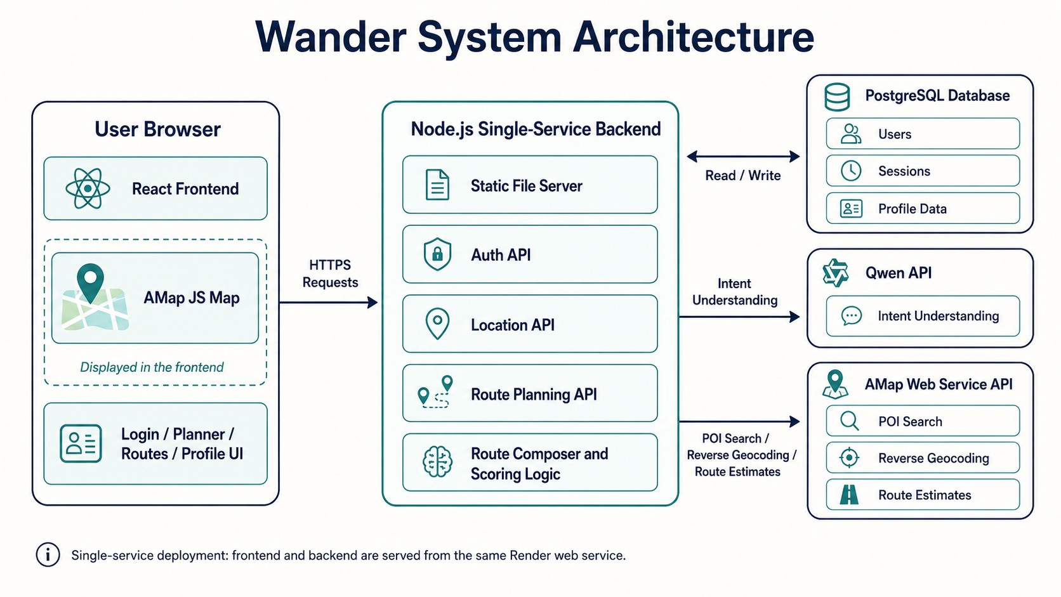
Component overview
Wander is implemented as a single-service web application. The main system components are the React frontend, Node.js backend, PostgreSQL database, Qwen API, AMap Web Service API, and AMap JavaScript map. Together, these components support the full user journey from login and location selection to route generation, route editing and navigation.
The React frontend is the user-facing part of Wander. It includes the login page, onboarding page, homepage planner, route planning page, route detail view, map interaction and profile page. React was suitable because Wander has several reusable and stateful interface elements, such as route cards, location search boxes, time selectors, travel mode selectors and stop detail panels. React’s component model supports this kind of reusable interface structure (React, n.d.).
The Node.js backend handles server-side logic. It serves the built frontend files and exposes API endpoints for authentication, location search, reverse geocoding and route generation. This means Wander can be deployed as one service rather than separating the frontend and backend into two different deployments.

The PostgreSQL database stores persistent user data. This includes registered user accounts, password hashes, sessions and profile information. PostgreSQL was chosen because the project moved beyond a pure prototype and needed proper account persistence rather than only browser local storage. PostgreSQL is a mature relational database system suitable for structured data storage (PostgreSQL Global Development Group, 2026).
The Qwen API is used for natural-language understanding. When a user enters a request such as “I want hotpot, a movie, and a park walk,” Qwen helps convert this flexible sentence into structured route requirements, including categories, keywords, stop signals and route styles. However, Qwen does not directly decide the final venues. The final places are validated through map data.
The AMap Web Service API provides real-world location data. It is used for address search, reverse geocoding, POI search and route estimates. AMap was important because Wander targets users in Chinese cities, and local POI coverage is essential for making the routes realistic and executable. AMap’s Web Service APIs provide HTTP-based access to map and location services (AMap, n.d.).
The AMap JavaScript Map is displayed in the browser. It allows users to see their current area, adjust the start point manually and understand the route visually. This is important because browser GPS can be inaccurate, so users need a way to correct their start location before generating a route.
Data flow
A typical user interaction begins when the user opens Wander and logs in. After logging in, the user can choose a start point. This can be done through GPS, manual map selection or address search. The frontend stores this selected start point as part of the planning state.
Next, the user enters a natural-language request, selects a time budget and chooses a travel mode such as walking, riding or taxi. When the user clicks the route generation button, the frontend sends a request to the backend through the route generation API. The request includes the user’s prompt, latitude and longitude, start location label, time budget, selected language and travel mode.
The backend first uses AMap reverse geocoding to convert the location coordinates into a readable place or nearby address. It then sends the user request and context to Qwen. Qwen returns structured planning information, such as required categories, search terms, stop signals and possible route styles.
After Qwen returns the structured intent, the backend uses AMap to search real POIs for each required stop. For example, if the user asks for hotpot, cinema and park, the backend searches for real hotpot restaurants, cinemas and parks near the user’s start point. The route planner scores candidate places based on keyword relevance, distance, rating, metadata and feasibility within the time budget.
Finally, the route composer builds three route options. Each route contains real stops, estimated travel time, stop duration, route summary and navigation links. The frontend displays these route options to the user. The user can then select a route, view stop details, open navigation, remove unwanted stops, add new stops or manually reorder the route.
Section 2 — Technology Justification
Technology / Tool | What we chose | Alternatives considered | Why we chose this
Frontend framework | React + Vite | Static HTML/CSS, Vue | React supports reusable stateful components for login, planner, routes and profile pages. Vite made development and production builds faster.
Backend | Node.js single-service backend | Python FastAPI, serverless functions, separate backend service | Node.js works well with the JavaScript frontend and async API calls. A single service simplified deployment.
Database | PostgreSQL | Browser localStorage, local JSON file | PostgreSQL provides persistent multi-user storage for accounts, sessions and profiles.
AI service | Qwen API | Pure keyword rules, other LLM APIs | Qwen handles flexible Chinese and English requests better than fixed rules. Final POIs are still validated through map data.
Map service | AMap Web Service API + AMap JS Map | OpenStreetMap, OpenRouteService | AMap gives stronger China POI coverage, address search and navigation support than open-source map data.
Deployment | Render Web Service | Local-only deployment, self-hosted server | Render supports GitHub deployment, HTTPS, environment variables and PostgreSQL with low setup effort.
The main technical risk was that route generation depends on external services. Qwen and AMap can be slow, unavailable or limited by API quota. To reduce this risk, the backend uses timeout handling and fallback logic. Another risk was GPS inaccuracy in browsers. During testing, the detected location could be tens of meters away from the user’s real start point, so we added manual map selection and address search. A third risk was LLM hallucination. To manage this, Qwen is only used to understand the user’s intent, while final places are selected from real AMap POI results. This design makes the route more reliable than asking the LLM to invent a full route directly.
Section 3 — Deployment Guide
Environment requirements
Requirement | Version / Notes
Node.js and npm | Node.js 18+ recommended. The project uses npm scripts for build and start.
Git | Required to clone the GitHub repository and deploy through Render.
PostgreSQL | Required for production user accounts and sessions. Render PostgreSQL can be used.
API keys | Qwen/DashScope API key, AMap Web Service key, AMap JavaScript key and AMap security code are required.
Setup steps
1. Clone the repository: https://github.com/iliufe/Wander.git
2. Install dependencies: npm install
3. Configure environment variables:
DASHSCOPE_API_KEY=your_qwen_key
DASHSCOPE_BASE_URL=https://dashscope.aliyuncs.com/compatible-mode/v1
QWEN_INTENT_MODEL=qwen-plus
AMAP_WEB_SERVICE_KEY=your_amap_web_service_key
VITE_AMAP_JS_KEY=your_amap_javascript_key
VITE_AMAP_SECURITY_JSCODE=your_amap_security_jscode
DATABASE_URL=your_postgresql_connection_string
POSTGRES_SSL=true
4. Run the application:
npm run build
npm start
5. Verify it is working: http://localhost:8788
Common issues and solutions
List at least 2 problems a new user might encounter and how to resolve them.
Problem | Likely cause | Solution
Frontend build not found | The disk/ folder does not exist because the frontend has not been built. | Run npm run build before running npm start.
Map does not load | AMap JavaScript key or security code is missing, incorrect or not allowed for the current domain. | Check VITE_AMAP_JS_KEY and VITE_AMAP_SECURITY_JSCODE, then rebuild and restart the app.
Route generation fails | Qwen or AMap Web Service key is missing, expired or rate-limited. | Check DASHSCOPE_API_KEY and AMAP_WEB_SERVICE_KEY in local env or Render environment variables.
Section 4 — IP Strategy
Novelty analysis
Wander is not completely novel as a broad AI route-planning idea. Existing products and patents already cover AI travel planning, POI-based route optimization and language-model-assisted navigation. For example, WayGenAI provides AI-generated optimized routes from user ideas, and Triply helps users turn saved places into trip plans. There is also a U.S. patent application describing the use of a language model for localization and route planning in navigation systems (Wu et al., 2024).
Wander’s novelty is more specific and contextual. It focuses on short spontaneous outings in Chinese cities rather than long vacation planning. The system combines current or manually corrected start location, time budget, travel mode, Qwen-based intent understanding, AMap real POI retrieval, saved personal addresses and editable multi-stop route options. This makes Wander different from general AI trip planners because it is designed for immediate local execution after class or work.
Prior art (2–3 examples)
Existing product / patent | What it does | How your solution differs
WayGenAI — https://www.waygen.ai/ | WayGenAI is an AI route planner that creates optimized routes from user ideas. | Wander focuses on short local outings in Chinese cities and uses AMap-based real POI retrieval around the user’s current start point.
Triply — https://triplyplanner.com/ | Triply helps users turn saved places or travel ideas into planned itineraries. | Wander starts from immediate free-time intent, not mainly from saved travel inspiration. It also includes time budget, travel mode and local route editing.
US20240418515A1 — Using a language model to localize and route plan for navigation systems | This patent application describes using a language model to support localization and route planning in navigation systems. | Wander does not claim broad LLM navigation. It applies Qwen to intent parsing while AMap validates real places and route feasibility.
Patent decision
We would not seek a patent at this stage. Wander is mainly a software product, and the broad idea has strong prior art in AI itinerary planning, POI-based route optimization and language-model-assisted navigation. A Chinese invention patent would take too long and cost too much for a student team. A Chinese utility model is also not suitable because Wander is not a hardware or structural invention. The current novelty is useful for product differentiation, but it is probably not strong enough for a defensible patent claim.
Alternative protection
The better protection strategy is trade secret protection combined with first-mover advantage. The most valuable parts of Wander are the prompt structure, route scoring logic, category mapping, fallback rules, API integration workflow and user feedback data. These should remain private in the backend codebase and be protected through repository access control, environment variables and database permissions. If the team later open-sources part of the project, it should only open-source non-sensitive frontend components or demo materials, while keeping route ranking logic and API configuration private.
Section 5 — Limitations & Future Work
Known limitations

Limitation | Why it exists | Impact on users
Route generation can be slow or fail | The system depends on external APIs such as Qwen and AMap, which may have latency, timeouts or quota limits. | Users may wait longer than expected or see a route generation failure.
Browser GPS is not always accurate | Web geolocation depends on the device, browser, network and indoor environment. | The detected start point may be slightly wrong, so the user may need to correct it manually.
POI quality depends on AMap data | Wander retrieves real places from AMap, so the result quality depends on AMap’s POI coverage and metadata. | Some niche requests may produce weaker or fewer route candidates.
Route editing is still basic | Users can add, remove and reorder stops, but the route is not fully re-optimized after every manual edit. | Edited routes may not always have the best possible order or travel time.
Future work
Feature or improvement planned — The next planned improvement is a background route-generation queue. This would allow route planning to continue more reliably even if the user switches pages or if external APIs respond slowly. Another important feature is a POI cache for common searches such as hotpot, cinema, cafe, park and supermarket, which would reduce repeated AMap requests and improve speed.

Technical debt to address — The route planning logic should be modularized further into separate services for intent parsing, POI retrieval, candidate scoring, route composition and route copy generation. Error handling should also be standardized across frontend and backend. Automated tests should be added for authentication, route generation, API failure handling and route editing.

Open research question — The main open research question is how to measure whether a generated route truly satisfies subjective user intent. Simple keywords such as “hotpot” or “cinema” can be verified with POI names and categories, but subjective requests such as “somewhere relaxing,” “not too crowded,” or “good for a date” require richer data. Future versions may use user feedback, UGC tags and route-following behavior to improve route ranking.
References
- Alibaba Cloud. (2026). Qwen API reference. Alibaba Cloud Model Studio. https://www.alibabacloud.com/help/en/model-studio/use-qwen-by-calling-api
- AMap. (n.d.). Web Service API documentation. AMap Open Platform. https://lbs.amap.com/api/webservice/summary
- PostgreSQL Global Development Group. (2026). PostgreSQL documentation. https://www.postgresql.org/docs/current/

- React. (n.d.). Your first component. React Documentation. https://react.dev/learn/your-first-component
- Render. (n.d.). Web services. Render Documentation. https://render.com/docs/web-services
- Triply. (n.d.). Triply AI trip planner. https://triplyplanner.com/
- WayGenAI. (n.d.). AI route planner. https://www.waygen.ai/
- Wu, S., Laprise, D., & Wheeler, M. (2024). Using a language model to localize and route plan for navigation systems and applications (U.S. Patent Application Publication No. US20240418515A1). Google Patents. https://patents.google.com/patent/US20240418515A1/en

